**TIMECARD ONLINE will now be a new tab available  
through the EMPLOYEE ONLINE product.**



SAVE to revisit at a later date, and to calculate totals

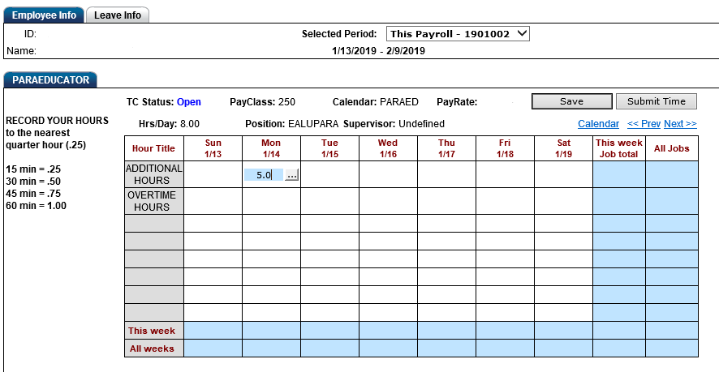STEP 1: Choose from an open pay period

STEP 2: ENTER hours (rounded to nearest .25 hours) on the appropriate dates, under the applicable program and hour. Use the “Next” or “Prev” link to move between open weeks.

STEP 3: SUBMIT to send for approval

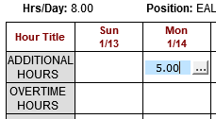

STEP 3: Click into the hours entered to display an ellipsis box.

A Detailed Time Entry panel will pop up. Here you will provide a short description of work performed. You can describe the whole amount, or split the hours between projects as applicable. When completed click on the SAVE button.

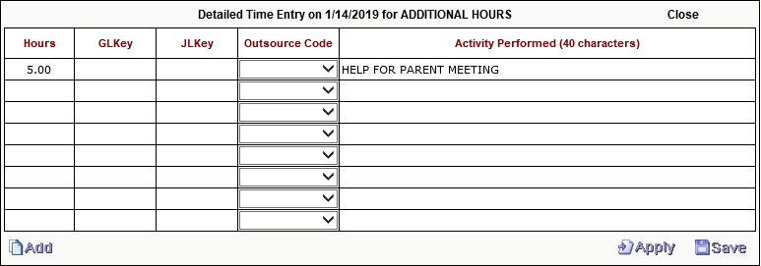

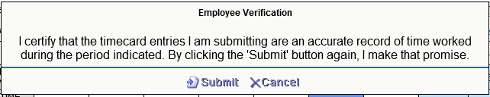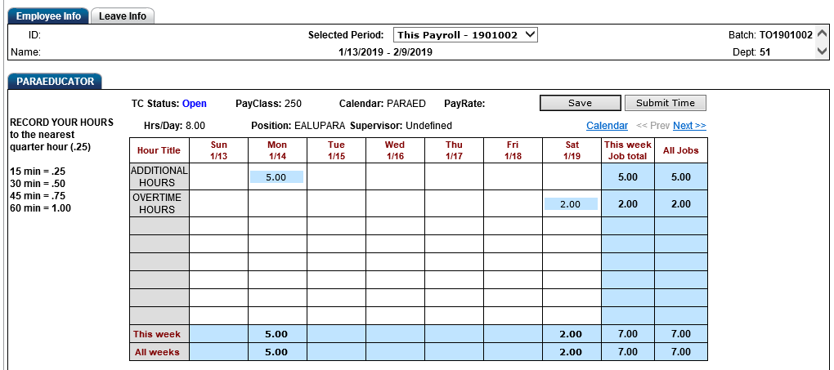

SAVE to revisit at a later date, and to calculate totals

STEP 4: SUBMIT to send for approval

STEP 4: Before clicking on SUBMIT, be sure you have entered ALL your additional time for the entire pay period identified (i.e. typically a 4-week period). This means you will submit only one time per month. Once submitted, the records will route for budget authorization and you will not be able to add or edit the records. If an error has been identified, you will need to contact your department timekeeper.

Failing to submit your time by the Payroll Calendar submission deadlines may result in delayed payment.

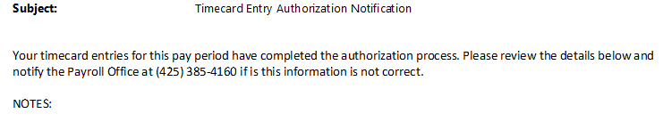You will receive an email, as shown below, once your records have completed the electronic approval process.

**ADDITIONAL HOURS:** used when hours are worked beyond assignment time OR on a district-paid HOLIDAY

**OVERTIME HOURS:** used when hours recorded are over and above a 40-hour work week OR on a SATURDAY